
Canva
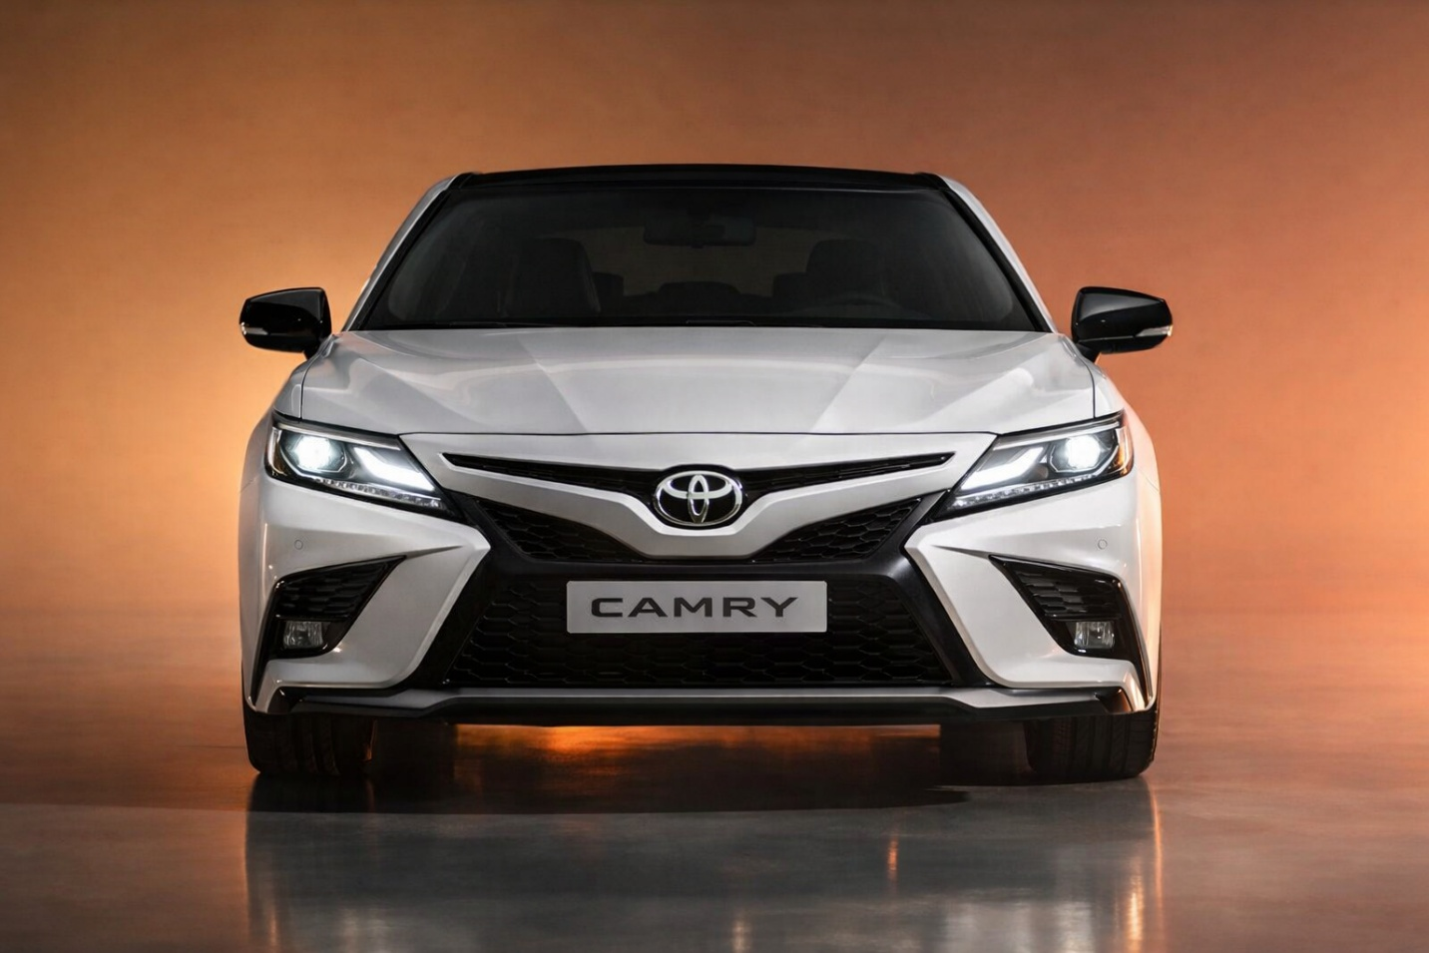
All images made by ChatGPT, because I liked the background, it make it like luxury rental place
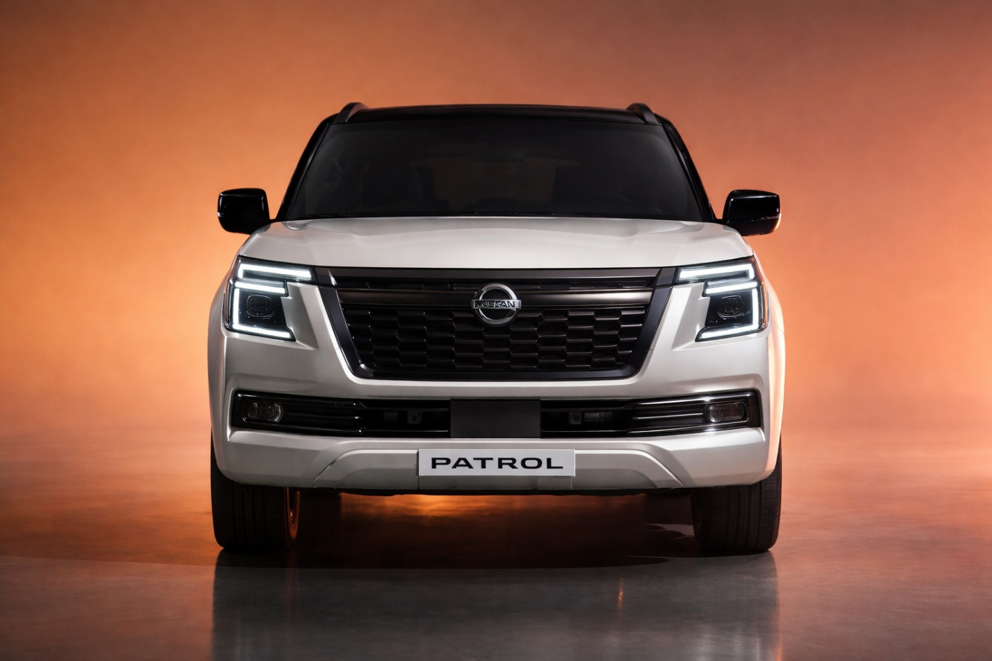
Link : https://www.team-bhp.com/news/nissan-patrol-may-come-india-2026-land-cruiser-rival

Advanced Features Implemented in Part 5

1. Booking Page (booking.html)

A dynamic car booking system was developed.
Users can:
- Select a car
- Choose start and end dates
- Automatically calculate number of rental days
- Automatically calculate total price

JavaScript was used to:
- Calculate total rental price
- Validate booking inputs
- Ensure correct date selection

This feature simulates a real car rental booking system.

2. FAQ Page (faq.html)

A Frequently Asked Questions page was created.
Users can:
- Click on questions
- Show or hide answers dynamically

JavaScript was used to:
- Create an accordion-style FAQ system
- Improve user interaction

This feature helps users quickly find answers.

3. Review Page (review.html)

A customer review system was implemented.
Users can:
- Enter their name
- Submit a review
- See their review displayed instantly

JavaScript was used to:
- Dynamically add reviews
- Validate empty inputs

This feature enhances user feedback interaction.

